Day -4 Assignment
1. Open your own laptop or desktop (or use an online PC hardware simulator if you don't have access to a real system) and identify the GPU model installed. Write down the GPU's brand, model number, and whether it is integrated or dedicated.

Item | Details
GPU Brand | Intel
GPU Model | Intel(R) Iris(R) Xe Graphics
Type | Integrated GPU
Version | 32.0.101.7084

2. Take a clear photo or screenshot of the cooling system (fan, heatsink, or liquid cooling setup) inside your PC or from a PC hardware simulator. Label the main cooling components and briefly describe their function.

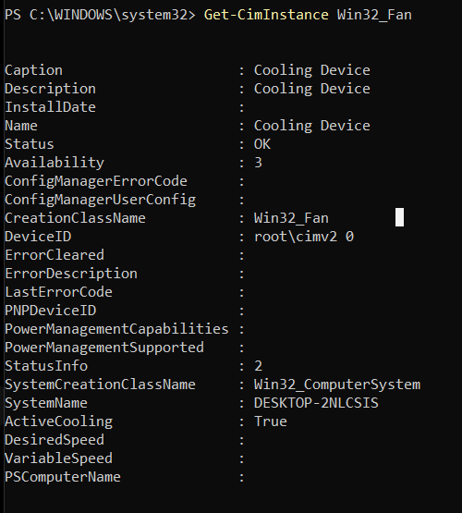

Component | Function
CPU Fan | Moves air to cool the CPU.
Heatsink | Absorbs heat from the CPU and spreads it away.
Heat Pipe | Transfers heat from the CPU to the heatsink.
Thermal Paste | Helps transfer heat from the CPU to the heatsink.
Cooling Vents | Allow hot air to leave and cool air to enter.
3. Create a comparison table listing at least 3 differences between air cooling and liquid cooling systems for GPUs, including factors like cost, efficiency, and maintenance.

Feature | Air Cooling | Liquid Cooling
Cost | Low | High
Cooling Efficiency | Good | Very Good
Maintenance | Low and easy | Higher and more difficult
Noise | Can be louder at high load | Usually quieter
Installation | Requires occasional dust cleaning only. | Requires monitoring of coolant, tubing, and pump; more maintenance.
Use Case | Normal gaming and everyday PCs | High-end gaming and performance PCs

4. Imagine you are building a gaming PC for streaming IPL matches and playing graphics-heavy games. Choose between air cooling and liquid cooling for your GPU, and justify your choice in 3-4 sentences based on your research.

Choice: Liquid Cooling
- Better cooling: Keeps the GPU cooler during heavy gaming and streaming.
- High performance: Suitable for graphics-heavy games and long gaming sessions.
- Lower temperature: Helps prevent GPU overheating during high workloads.
- More expensive: Costs more than air cooling.
- Maintenance: Requires more care, but is suitable for a high-performance gaming PC.

